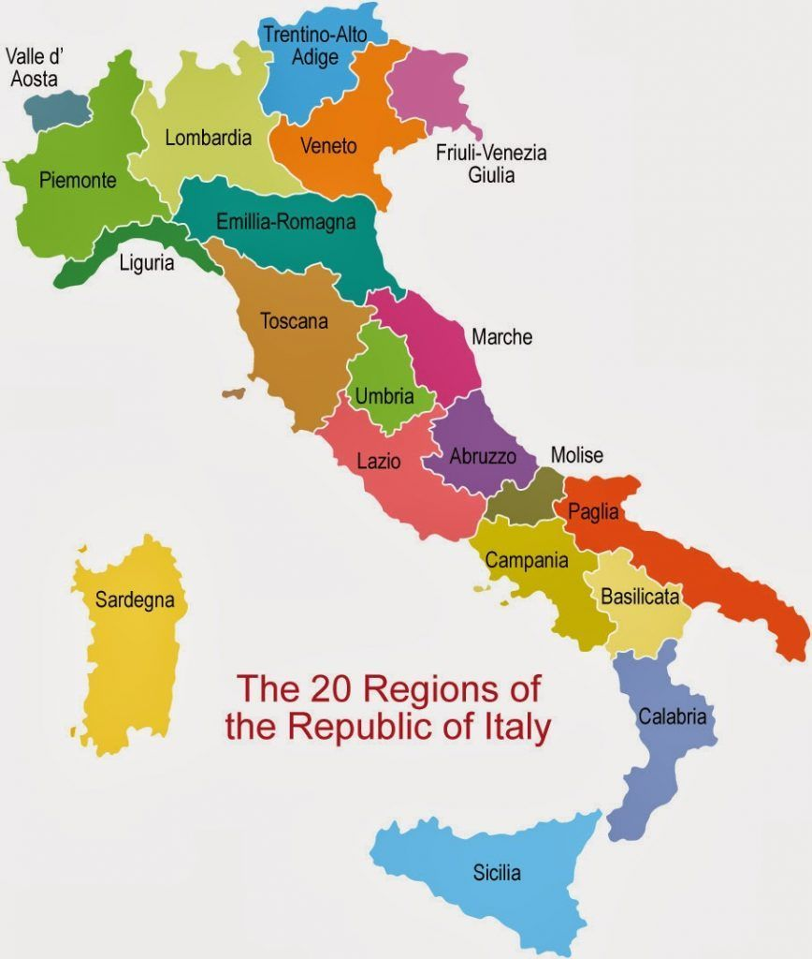

A Holiday in Italy
Read the conversation between Tim and Alan, then answer the questions below.
Tim: Alan, do you want to see the pictures of my holiday in Italy?
Alan: Sure, what was it like?
Tim: Ah, the holiday was great! The food was great! The wine was great! The traffic was horrible!
Alan: Why was the traffic horrible?
Tim: Those Italians are crazy drivers! I don't want to think about it!
Alan: OK, OK, let's return to the good parts ...
Tim: Yes, so here's a picture of the Leaning Tower of Pisa.
Alan: Incredible!
Tim: It was raining that day, but it was still wonderful. We climbed to the top!
Alan: And what's this?
Tim: That's a photo of the Arno river, in Florence. That's the 'Ponte Vecchio' the old bridge.
Alan: What was Florence like?
Tim: It was very interesting. There were beautiful old medieval buildings in the city, impressive cathedrals and churches, and lots of wonderful museums.
Alan: How was your Italian?
Tim: My Italian wasn't very good. But many Italians speak English very well. I was impressed!
Alan: Oh, this one is nice.
Tim: Yes, that's a shot of a tasty pizza served by a beautiful Italian!
Alan: She is beautiful, isn't she?
Tim: Ah, yes, the land of fashion, food and wine. I'd recommend Italy anytime!
Alan: I'm so jealous...

Q 1: What wasn't great about Italy?
- The wine
- The food
- The traffic

Q 2: Which city did he not mention?
- Florence
- Pisa
- Rome

Q 3: How did they get to the top of the leaning tower of Pisa?
- By elevator
- On foot
- By escalator

Q 4: Which river does the Ponte Vecchio cross?
- The Arno
- The Pisa
- The Tiger

Read the text and think about questions you may want to ask your reading partner.

My kind of place: Pisa, Italy.
There's more to this Tuscan town than its famously off-kilter architectural landmark
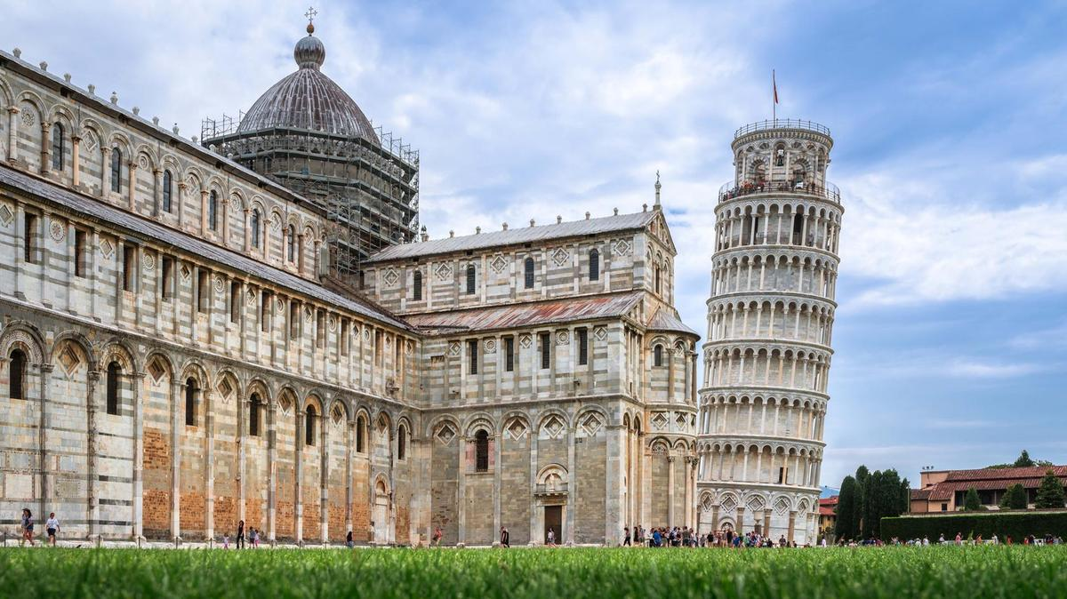The Leaning Tower of Pisa. The travel and tourism industry are one of the hardest hits by the pandemic. Getty

Why Pisa?
Pisa is a beautiful little Tuscan city on the River Arno, which because everyone flocks to nearby Florence, remains decidedly unexplored by comparison. With one obvious exception: the UNESCO World Heritage Site, Square of Miracles– the location of one of the most recognisable buildings in the world, the Leaning Tower of Pisa. But there’s plenty more to see in this lovely city.
Located directly opposite Pisa Centrale, NH Pisa has smart modern rooms (the superior doubles and family rooms are the best) and very friendly staff. Double rooms cost from €85 (Dh384), which includes breakfast. The Royal Victoria Hotel has a great location beside the River Arno and plenty of old-world charm. Double rooms cost from €85, including breakfast. Alternatively, if you’re happy to stay just outside Pisa, Hotel Plaza e de Russie is an excellent choice in Viareggio – just across the road from the beach, with impeccable service and a Michelin-starred restaurant. Double rooms cost from €85, which includes breakfast

Find your feet
The large Square of Miracles, and the buildings that stand on it, are what bring most people to Pisa in the first place. The Romanesque cathedral and baptistery (the largest in Italy), the monumental cemetery, and the bell tower (better known as the Leaning Tower of Pisa – it had started to lean before it was even completed) collectively form one of the most remarkable groups of medieval buildings anywhere in the world.
But the city is full of other things worth seeing, which the majority of visitors sadly miss. Just off Piazza Vittorio Emanuele II, on the exterior of the church of Sant’Antonio Abate, there’s a huge mural by the late American pop artist Keith Haring (Tuttomondo, painted in 1989). There’s the Palazzo Blu, a museum beside the Arno that, as well as its permanent collection, stages some excellent temporary exhibitions; past shows have included retrospectives of works by Andy Warhol, Amedeo Modigliani and M C Escher. Santa Maria Della Spina is also a beautiful little Gothic church beside the river.
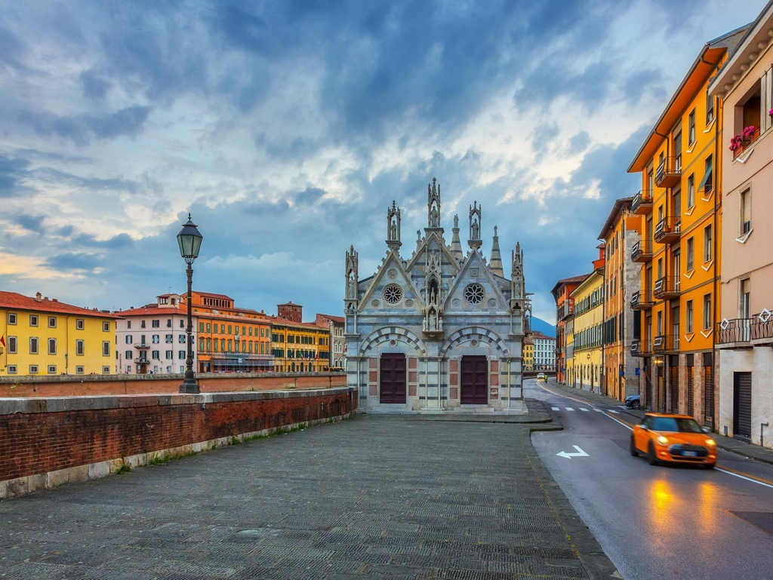The Santa Maria Della Spina. Getty

You can visit the Botanical Gardens of the University of Pisa, established in the 16th century; or spot the house where Galileo Galilei, the hugely influential 17th century astronomer and physicist, was born, on Via Giusti. And then there’s the wonderful view across the Arno from the “lungarnos”, the roads running alongside the river. The sweep of multi-coloured facades that line the river, bathed in light, is quintessentially Tuscan.
If you have time to explore beyond the city centre, it’s 15 minutes by train to Viareggio – home of Tuscany’s top beach, and Italy’s most spectacular carnival. While not as well known outside Italy as the carnival in Venice, nothing tops Viareggio in terms of sheer scale – the floats are gigantic.

Meet the locals
The market on Piazza delle Vettovaglie is a lively spot where locals gather to buy fresh fruit and vegetables in the mornings, or else stop for a coffee.
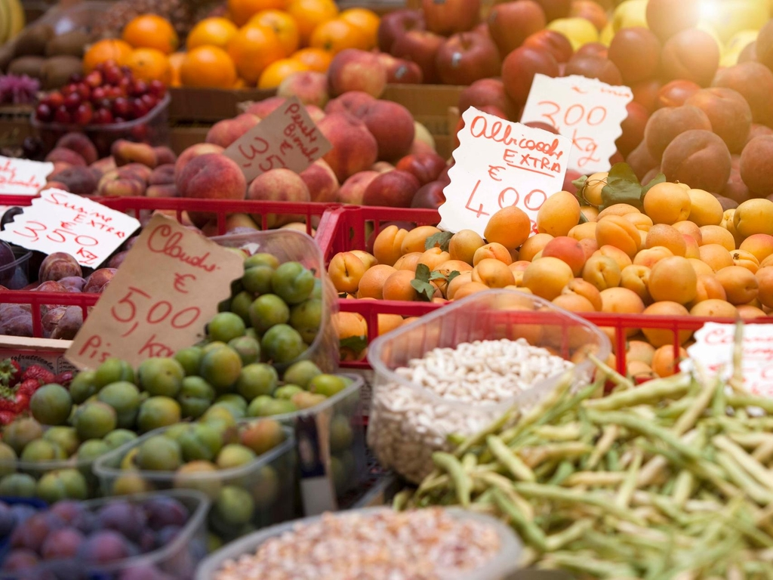The market on Piazza delle Vettovaglie offers fresh produce Getty

Book a table
Osteria di Culegna, on Via Mercanti, serves typical Tuscan dishes – entrees along the lines of ricotta and spinach ravioli go for around €9, while dishes such as beef fillet with pine nuts and thyme, served with new potatoes, cost around €15.
Da Antonio, on Via Santa Maria, is a decent place to eat near the Tower, with tasty pasta dishes and pizzas from around €9. If you’re in Viareggio, don’t miss Lunasia, where Michelin-starred chef Luca Landi serves up exquisitely prepared seafood and other dishes. The five-course degustation menu is excellent value at under €90.

Shoppers’ paradise
Corso Italia, which runs between Piazza Vittorio Emanuele II and the Arno, is the city’s main shopping street.

Don’t miss
The Leaning Tower. Some famous buildings or landmarks can be underwhelming when you finally see them up close. Not this one. Whatever you’ve seen or read about it, the elegant lop-sided Romanesque bell tower, whose architect remains unknown, is an amazing piece of architecture. It was re-opened to the public in 2001 after being closed for over a decade, during which time it was stabilised to reduce its lean slightly and prevent it from collapsing. The views from the bell chamber, when you finally get there, are simply phenomenal.

What to avoid
Bear in mind that entry to the Leaning Tower is based on allotted time slots, and there’s a strict no bags policy for entering the tower. There’s a secure locker room next to the ticket office where you can leave your belongings. It is free to use but the queue can be quite long, so allow plenty of time to get a locker before your chosen entry time to the tower. Alternatively, you could leave your bag at your hotel.

Getting there
Emirates flies direct from Dubai to both Bologna and Rome, with return flights including taxes from Dh2,875 and Dh2,765 respectively, while Etihad flies from Abu Dhabi to Rome from Dh2,925 return, including taxes. The train from Bologna takes 90 minutes to arrive at Pisa, and the route takes you via Florence, while the trip from Rome to Pisa takes 2 hours 30 minutes by train. Domestic flight from Rome to Pisa brings the journey time down to 50 minutes.

