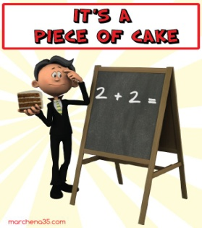

**Match the following idioms with their example sentences below.**

**Then complete each blank according to the pictures. Make any necessary changes.**

**wake up**

**and smell the**

**(to pay attention to what’s going on)**

**have bigger**

**to fry**

**(have more important things to do)**

**bring home the**

**(to earn a salary)**

**be (like) two**

**in a pod**

**(to be very similar)**

**spill the**

**(to reveal something secret)**

**be in a**

**(to be in a difficult situation)**

**someone up**

**(to be extra nice to someone)**

**go**

**(to go crazy or be angry)**

**all and skittles**

**(all fun, easy and pleasant)**

**take the**

**(to be most annoying/surprising … thing that someone has done)**

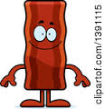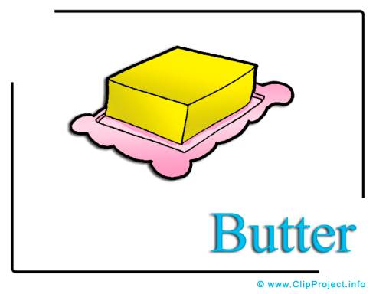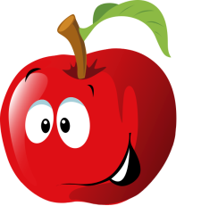

**the of one’s eye**

**(a person that is adored by someone)**

[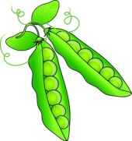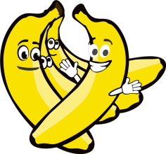](http://schools-demo.clipart.com/search/close-up?oid=5091573&q=peas&s=1&a=c&cid=&fic=0&k_mode=all&k_exc=&q_jpeg=1&q_gif=1&q_color=1&q_eps=1&q_wmf=1&q_psd=1&q_png=1&date=&pubid=&isadv=1)

**have on one’s face**

**(to look stupid or embarrassed)**

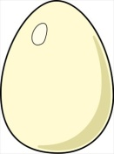

[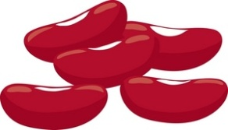](http://schools-demo.clipart.com/search/close-up?oid=3770295&q=beans&s=31&a=c&cid=&fic=0&k_mode=all&k_exc=&q_jpeg=1&q_gif=1&q_color=1&q_eps=1&q_wmf=1&q_psd=1&q_png=1&date=&pubid=&isadv=1)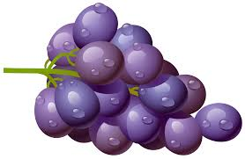

**belt the**

**(to drink wine/liquor**

**heavily and become intoxicated)**

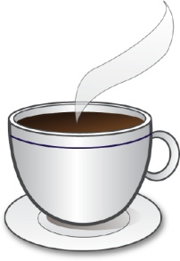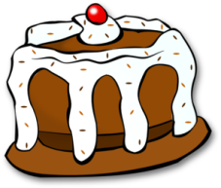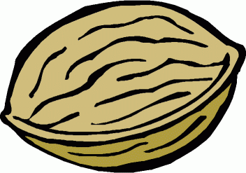

**a hard to crack**

**(a difficult problem to deal with)**

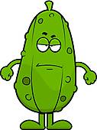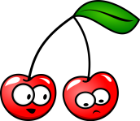

**get another**

**bite at the**

**(to get a 2nd chance at something)**

*I just ______________________ when she told me she wanted to move out.*

*You have done some stupid things before, but this really ______*

*______________________________.*

*We _______________________ - we like the same things and do everything together.*

*He has a tendency to _________*

*________________ - but his wife simply hates it when he is drunk.*

*I can’t help you right now – I ____________________________________________________________.*

*Things have changed around here, John! _____________________*

*______________________________!*

*For Sam, college was ___________________________. He just partied all the time.*

*I was completely wrong, and now I _________________________.*

*This word search is not easy to solve. It’s ______________________.*

*It’s about time you got a job so you can _______________________.*

*He’s failed his driving test but he will ________________________ next month.*

*You don’t need to ___________ _____________ - I’ll give you an A for the homework.*

*Don’t ____________________ _____________or we’ll end up in jail.*

*I _____________________ after ordering some pizza and then having no money to pay for it.*

*Baby Cindy is definitely* ***the apple******of*** *her father’s* ***eye****.*